**Facial Pay**

A Second Year Project Report

Submitted to the Faculty

of the

Bennett University

By

Ayushman Pranav, ,

E21CSEU0245, ,



Department of Computer Science Engineering

November 2019

Greater Noida-201310, Uttar Pradesh, India

**TABLE OF CONTENTS**

LIST OF TABLES……………………………………………………………………………. iii

LIST OF FIGURES…………………………………………………………………………… iv

1. INTRODUCTION……………………………………………………………………………1

1.1. Problem Statement……………………………………………………………………….1

2. Background Research.………………………………………………………………………..2

2.1. Proposed System..……………………………………………………………………… 2

2.2. Goals and Objectives.………………………………………………………………….. 3

3. Project Planning..…………………………………………………………………………… 4

3.1. Project Setup..………………………………………………………………………….. 4

3.2. Stakeholders..…………………………………………………………………………... 5

3.3. Project Resources.……………………………………………………………………… 6

3.4. Assumptions.…………………………………………………………………………… 7

4. SYSTEM ANALYSIS AND DESIGN..…………………………………………………….8

4.1. Overall Description..…………………………………………………………………… 8

4.2. Users and Roles..………………………………………………………………………. 9

4.3. User Stories(Requirements).……………………………………………………………10

4.4. Design diagrams/ UML diagrams/ Flow Charts/ E-R diagrams………………………..19

4.4.1. Use Case Diagrams..……………………………………………………………… 19

4.4.2. Class Diagram..……………………………………………………………………. 20

4.4.3. Activity Diagrams..………………………………………………………………… 21

4.4.4 Data Architecture..………………………………………………………………… 24

**LIST OF TABLES**

Table Page

Table 1: ………………………………………………………………………………………. 3

Table 2: ………………………………………………………………………………………...4

Table 3: …………………………………………………………………………….. …………5

Table 4: …………………………………………………………………………….. …………6

Table 5: ………………………………………………………………………………………...7

iii

**LIST OF FIGURES**

Figure Page

Figure 4.4.1: Use Case Diagram………………………………………………………………19

Figure 4.4.2: Class Diagram…………………………………………………………………...20

Figure 4.4.3: Activity Diagram………………………………………………………………...21

Figure 4.4.4: Data Architecture Diagram………………………………………………………24

iv

**1. INTRODUCTION**

Online transaction for all intents and purposes is a payment method in which the transfer of fund or money happens online over electronic fund transfer, which specifically is quite significant. Online transaction process (OLTP) particularly is essentially secure and password protected, fairly contrary to popular belief. Three steps involved in the online transaction actually are Registration, Placing an order, and, Payment, actually further showing how three steps involved in the online transaction generally are Registration, Placing an order, and, Payment in a pretty big way. Nowadays people don’t for all intents and purposes carry cash for payments, they definitely prefer UPI transactions for the same, demonstrating how nowadays people don’t generally carry cash for payments, they generally prefer UPI transactions for the same in a sort of big way.

But to make the transactions even simpler we can use human faces and facial recognition software to replace “QR Codes” so that you can become your wallet. Imagine if you can for all intents and purposes do transactions by your face.

**1.1. Problem Statement**

Nowadays, payments have been made so accessible that people forget to carry their card or cash and use their UPI to make payments from their smartphones. Would “Qr Codes” be replaced by face scans ?

**2. Background Research**

Face recognition payment is also a kind of mobile payment. It is a more representative high-tech payment method since the emergence of aggregate payment, and a high-tech intelligent self-service cashier that breaks through the security and technical barriers. And with the launch of WeChat face recognition payment interface for service providers, many service providers began to layout the market and penetrate to more merchant applications.

What are the advantages of FRP:

1. Lower cost and more convenient cashier methods

Currently FRP hardware are WeChat official provided to agents, and pay treasure is free to agents, and merchants use the FRP system, simple and convenient installation, for merchants, solve the peak flow problem, and make consumer cashier more convenient, why not?

2. Accurate identification to reduce the error rate

FRP uses high-tech biometric technology and computer graphics processing technology to identify, can accurately identify the face, the error rate is almost negligible, including intelligent recognition of static pictures, plastic surgery face, heavy makeup face, accurate recognition, so that consumers and merchants experience the real security.

3. High user acceptance rate

FRP adopts AI camera face recognition technology, which can complete the payment in a short time, reducing the queuing time of consumers, and making consumers feel the real convenient way to collect money, so many consumers are more willing to accept this collection method.

At the same time, FRP solves the following problems for merchants:

1. People flow problem during peak hours: self-service shopping has liberated the hands of merchant cashiers, and the cashier flow problem in peak hours has been improved.

2. Marketing problems: For large shopping malls, the landing of self-service face brushing payment and cashier equipment is also the landing of marketing problems. Consumers can recommend the goods to consumers according to the cashier system, and merchants can also expand the turnover.

3. Inventory problems: The face payment and cashier system is equipped with the ERP management system, which solves the problem of inventory counting and sorting out inventory for merchants.

4. Member stickiness: Face payment members are equipped with a management system, such as consumers need to register members, and can recommend related products according to members' purchasing habits, and can also realize marketing, such as membership discount, card voucher cancellation, holiday gifts and other activities.

https://www.linkedin.com/pulse/advantages-disadvantages-face-recognition-payment-suzy-feng/?trk=pulse-article

https://www.cnbc.com/2022/05/17/mastercard-launches-tech-that-lets-you-pay-with-your-face-or-hand.html

**2.1. Proposed System**

Utilize facial recognition system to make payments making payments more accessible and comfortable .Now you can do transactions with your faces that are already linked with your AADHAR and UPI Id.

**2.2. Goals and Objectives**

**Table 1:**

| **#** | **Goals or Objective** |
| --- | --- |
| 1 | Make the app extensible – future updates can be delivered easily |
| 2 | Make the system easy to support – provide good documentation, configuration/build files, administrator’s manual |
| 3 | Make the app visually appealing and user friendly – user shouldn’t be confused navigating the app |
| 4 | Build a prototype that demonstrates the user interface by 31/10/21 - in order to get early feedback from our backers |
| 5 | Gain marks from the project |

**3. Project Planning**

**3.1. Project Setup**

**Table 2:**

| **#** | **Decision Description** |
| --- | --- |
| 1 | Windows 11, macOS, Android, iOS, Arch Linux, Python, TensorFlow, Kotlin, Swift, Firebase, Stripe API, Git, etc. |
| 2 | Capstone coding standard, PEP 8, Google Kotlin Style Guide, Swift API Design Guidelines |
| 3 | MIT Licence |
| 4 | A Computer Vision AI will be set up at Google Servers that matches the customer environment (image provided by customer) |

**3.2. Stakeholders**

**Table 3:**

| **Stakeholder** | **Role** |
| --- | --- |
| End Users | Make use of app |
| Dr. Anshika Arora | Mentor and Instructor |
| Patrons | Coupons |
| Ayushman Pranav | Team Member |
|  | Team Member |
|  | Team Member |

**3.3. Project Resources**

**Table 4:**

| **Resource** | **Resource Description** | **Quantity** |
| --- | --- | --- |
| Google Firebase | A NoSQL database server provided by Google. | 1 |
| Capstone Team | Our team of students who will be the primary developers of the project. | 3 |
| Dr. Anshika Arora | The mentor who will be able to provide us with technical assistance. | 1 |
| Mac Workstation | A macOS workstation with Xcode for developing the iOS version of the software. | 1 |
| Windows Workstation | A Windows workstation with Android Studio for developing the Android version of the software. | 1 |
| Stripe API | Payment API to handle points transactions. | 1 |
| iPhone | An iPhone to be used as test hardware for the iOS version of the software. | 1 |
| Android Phone | An Android phone to be used as test hardware for the Android version of the software. | 2 |

**3.4. Assumptions**

**Table 5:**

| **#** | **Assumption** |
| --- | --- |
| A1 | The capstone team and mentors will be able to meet face to face once a week. |
| A2 | Google Firebase, and Stripe API will be available to use for the team. |
| A3 | Team members will be able to familiarise themselves with the Google Firebase, and SwiftUI Environment. |
| A4 | Object Recognition AI/ML Model will be completed by Milestone II and begin testing on big data. |
| A5 | The FrontEnd UI will be operational and connected with the Object Recognition API by Milestone III. |
| A6 | The app will be able to attract sponsors in the given timeframe. |
| A7 | Team will have sufficient time to complete the application by End-Semester. |

**4. SYSTEM ANALYSIS AND DESIGN**

**4.1. Overall Description**

This project is an attempt to make World’s Payment system more fluid by using data science and machine learning techniques combined with a futuristic social experience to incentivize users to switch from Qr to face scans for their payment needs .

A user registers in the app by face scan , aadhar, pancard ,linking bank upi and general details. Payment can be done simply by scanning the payer’s face then payee’s face theirafter entering the amount.

**4.2. Users and Roles**

**Table 6:**

| **User** | **Description** |
| --- | --- |
| Developer & Tester | A capstone team member who is tasked with creating the app, creating an AI algorithm for object recognition, managing the training and test data and ultimately generating a firm process for applying these techniques to future user data. |
| Mentor/Instructor | Provide support, help, and supervision throughout the development of the software project. |
| End Users | An end user who will be using the application to provide their details, gather points by dumping trash, uploading the pictures of trash, and share the app with their friends. |
| Companies Sponsors | Provides discount coupons to the users in exchange for their uses. |

**4.3. User Stories (Requirements)**

**4.3.1. Product Backlog Items**

**Table 7:**

| **ID** | **Feature name** | **Story points** |
| --- | --- | --- |
| 1 | App Creation | 8 |
| 2 | Face scan | 1 |
| 3 | User login/registration | 2 |
| 4 | Payment system | 8 |
| 5 | Leaderboard of Users | 1 |
| 6 | Bug Reports | 3 |
| 7 | View Progress Status | 3 |

**SPRINT 1**

**Estimated User Story Points: 12**

**Actual Completed User Story Points:** N/A

| **ID** | **Added** | **Description** | **Status** | **Story Points** | **Actual Equivalent Story Points** | | **% Completed** |
| --- | --- | --- | --- | --- | --- | --- | --- |
| 100 | Onset | *As a developer, I want to create an app so that users can interact with it.* | **T** | **8** |  | | **20%** |
| 200 | Onset | *As a tester, I want to overview the application so that I can remove the bugs.* | **T** | **3** |  | | **30%** |
| 300 | Onset | *As a user, I want to be able to login to the app so that I can interact with it.* | **C** | **1** | **1** | | **100%** |
| **Acceptance Criteria** | | | **Verification** | | | | |
| **110** | The app will be available to users on mobile devices. | | **Create a test case to verify the app is working for users on mobile devices.** | | | | |
| **112** | The tester can identify any bugs and report them. | | **Create a test case to identify bugs present in the application.** | | | | |
| **113** | When a user logs in, they will be able to view their details | | **Create a test case to verify information of the user displayed.** | | | | |
| **114** | When a user logs in, points will be visible to users in application | | **Create a test case to verify information is stored in the database.** | | | | |
| **ID** | **Tasks** | | | | | **Resource** | |
| *1* | *Create a register/login page which greets the user when they first open the app.* | | | | | **Ayushman Pranav** | |
| *2* | *Develop a functionality for the user to be able to register with their email and a unique password, or alternatively login with their Google* | | | | | **Ayushman pranav** | |
| *3* | *Enforce Object-Oriented and modular development for easy extensibility in the future.* | | | | | **Ayushman Pranav** | |
| *4* | *Constantly be up to date on enforcing the newest security protocols to protect user data and be on top of the bugs.* | | | | | **Ayushman Pranav** | |
|  |  |  |  |  |  |  |  |

**SPRINT 2**

**Estimated User Story Points:** 13

**Actual Completed User Story Points:** N/A

| **ID** | **Added** | **Description** | **Status** | **Story Points** | **Actual Equivalent Story Points** | | **% Completed** |
| --- | --- | --- | --- | --- | --- | --- | --- |
| 400 | Onset | *As a developer, I want to design an AI model so that the application can recognize faces.* | **C** | **8** | **8** | | **100%** |
| 500 | Onset | *As a user, I want to scan and capture Payer and Payee’s faces so that I can gain points.* | **T** | **1** |  | | **N/A** |
| 600 | Onset | *As a user, I want to see my wallet i.e money collected and sent so that I can keep track of my expenses.* | **T** | **2** |  | | **20%** |
| 700 | Onset | *As a user, I want to receive a message from app whether the payment has been sent or received or not.* | **T** | **1** |  | | **N/A** |
| **Acceptance Criteria** | | | **Verification** | | | | |
| **410** | The application will be able to recognize and identify scanned faces. | | **Create a test case to verify the objects are scannable.** | | | | |
| **411** | The application will be able to provide information about the scanned faces. | | **Create a test case to verify details of the objects.** | | | | |
| **413** | The user will be able to see their toal transactions. | | **Create a test case to verify the user is able to see their points and those of their friends.** | | | | |
| **414** | The user will be able to capture the face and view it on the application. | | **Create a test case to verify that the user can capture the image and view it on the application.** | | | | |
| **415** | The Developer should be able to see wallet i.e money collected and sent so that user can keep track of my expenses | | **Create a wallet for users to track their transactions** | | | | |
| **416** | The Developer should be able to send a message from app whether the payment has been sent or received or not. | | **Create message token of the amount of money to be sent or received from Payer to Payee** | | | | |
| **ID** | **Tasks** | | | | | **Resource** | |
| *1* | *Create a camera system in the app that can make use of the mobile phone’s camera to capture a face.* | | | | | **Ayushman Pranav** | |
| *2* | *Collect data to be used as train data and test data to develop the model.* | | | | | **Ayushman Pranav** | |
| *3* | *Develop a sequential convolution neural network using the train data.* | | | | | **Ayushman Pranav** | |
| *4* | *Improve the accuracy of the model where it’s lacking.* | | | | | **Ayushman Pranav** | |
| *5* | *Develop functionality to keep track of user transaction after they capture more faces.* | | | | | **Ayushman Pranav** | |
| *6* | *Develop functionality in the form of a wallet to display transactions.* | | | | | **Ayushman Pranav** | |
|  |  |  |  |  |  |  |  |
|  |  |  |  |  |  |  |  |

**SPRINT 3**

**Estimated User Story Points:** 3

**Actual Completed User Story Points:** N/A

| **ID** | **Added** | **Description** | **Status** | **Story Points** | **Actual Equivalent Story Points** | | **% Completed** |
| --- | --- | --- | --- | --- | --- | --- | --- |
| 800 | Onset | *As a Mentor, I want to be able to see the project progress so that I can help the team members if they are stuck.* | **T** | **3** |  | | **50%** |
| **Acceptance Criteria** | | | **Verification** | | | | |
| **810** | The Mentor will be able to see the project progress by team members. | | **Create a test case for the mentor to see the project progress.** | | | | |
| **811** | The Mentor will be able to provide help and supervision to the team members. | | **Create a test case for the mentor’s supervision.** | | | | |
| **ID** | **Tasks** | | | | | **Resource** | |
| *1* | *Oversee that all operations are being carried out smoothly and provide advice to improvise the project.* | | | | | **Dr. Anshika Arora** | |
| *2* | *Create a git repository with all the information about the project and the source code for the mentor to check.* | | | | | **Ayushman Pranav Ayushman Pranav**  **Ayushman Pranav** | |
|  |  |  |  |  |  |  |  |

**SPRINT 4**

**Estimated User Story Points:** 6

**Actual Completed User Story Points:** NA

| **ID** | **Added** | **Description** | **Status** | **Story Points** | **Actual Equivalent Story Points** | | **% Completed** |
| --- | --- | --- | --- | --- | --- | --- | --- |
| 900 | Onset | *As a user, I want to see my wallet i.e money collected and sent so that I can keep track of my expenses.* | **T** | **3** |  | | **N/A** |
| 1000 | Onset | *As a sponsor, I want to provide coupons to the users in exchange for no. of transactions so that I can market my brand****.*** | **T** | **3** |  | | **10%** |
| **Acceptance Criteria** | | | **Verification** | | | | |
| **910** | When a user passes a certain no. of transactions they will receive a discounted coupon from the sponsor. | | **Create a test case to verify that when a user exchanges points with a sponsor, they will receive a discounted coupon from that sponsor.** | | | | |
| **911** | The user will be able to see a list of coupons and the discounts they offer. | | **Create a test case to verify that the user will be able to see a list of sponsors and the discounts they offer.** | | | | |
| **913** | The user will be able to see how many transactions they have available to exchange them with coupons. | | **Create test cases to verify that the user will be able to see how many points they have available to exchange.** | | | | |
| **914** | The sponsors will be able to market their company's brand by providing coupons to users. | | **Create a test case to verify that the sponsors will be able to market their company's brand by providing coupons to users.** | | | | |
| **ID** | **Tasks** | | | | | **Resource** | |
| *1* | *Create a coupon page with all available deals with the number of transactions required to acquire them.* | | | | | **Ayushman Pranav** | |
| *2* | *Develop a functionality that checks if the user has the required number of transactions and accept/deny accordingly.* | | | | | **Ayushman Pranav** | |
| *3* | *Develop a functionality to update total user transactions after the user exchanges some for a coupon.* | | | | | **Ayushman Pranav** | |
|  |  |  |  |  |  |  |  |
|  |  |  |  |  |  |  |  |

**4.4. System Design - UML diagrams**

**4.4.1. Use Case Diagram**

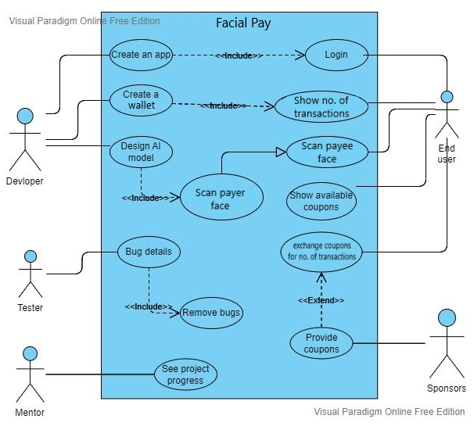

**4.4.2. Class Diagram**

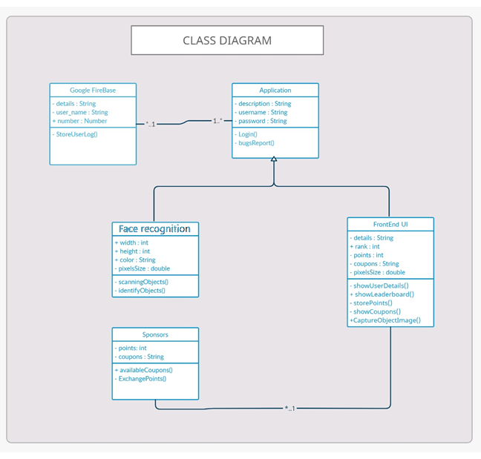

**4.4.3. Activity Diagrams**

**4.4.3.1. User Login System**

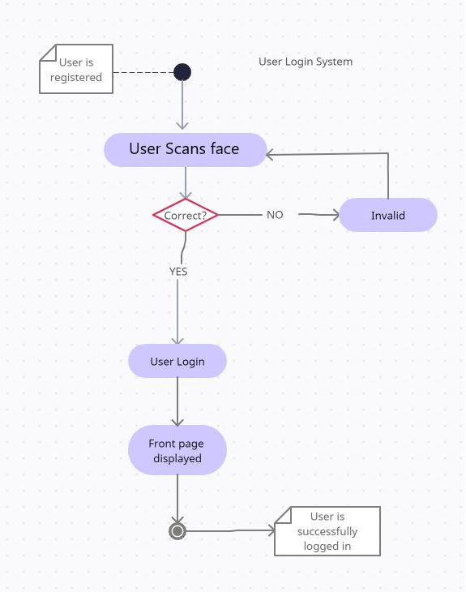

**4.4.3.2. Face pay System**

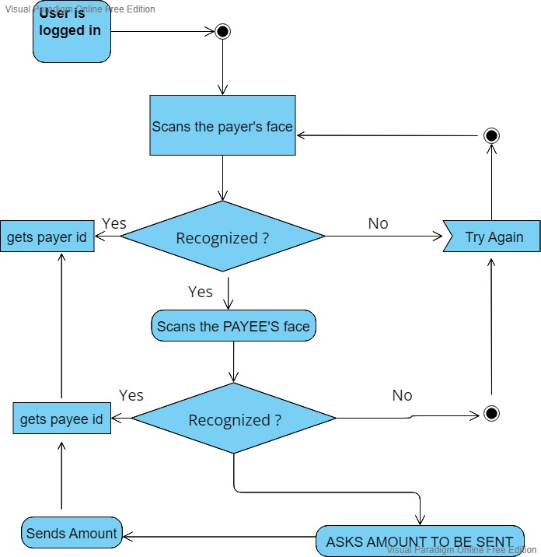

**4.4.3.3. Coupon Exchange System**

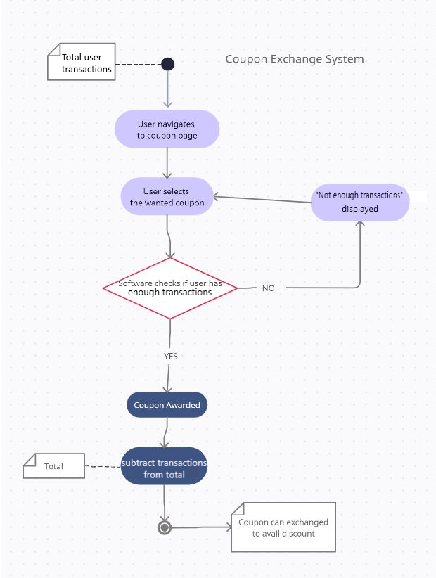

**4.4.4. Data Architecture**

